13.3 Measurement Tools for Curves
Today we will cover arc length and curvature focusing on how to compute the formulas and giving some motivation.
Preview of tools
Arc Length
$$s\left(t\right)=\int_{0}^{t}{\left|r^{'}\left(u\right)\right|du}=distance (arc length)$$

Curvature
3D Formula: $κ\left(t\right)=\frac{\left|r^{'}\left(t\right)×r^{''}\left(t\right)\right|}{{\left|r^{'}\left(t\right)\right|}^{3}}$
2D Formula: $κ\left(x\right)= \frac{|f^{''}\left(x\right)|}{{\left(1+{\left(f^{'}\left(x\right)\right)}^{2}\right)}^{3/2}}$
TNB-Frame (we will discuss in 13.4)

Part 1: Arc Length (i.e. Distance) HW 13.3 / 1–3
Sp’19 – Exam 1 – Loveless
Find the distance along the curve
$$r\left(t\right)=〈t^{3},3t^{2},6t〉$$
from (0, 0, 0) to (1, 3, 6).
Visual: https://desmos.com/3d/h75znwwviz
Example 1 HW 13.3 / 7
My slinky is a helix that has a radius of 1.4 inches, it has 39 turns, and it is 2.5 inches tall when collapsed. How long is it?
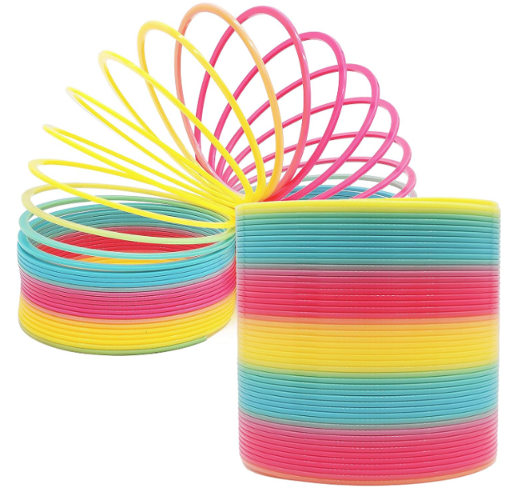
Example 2 HW 13.3 / 3
Let C be the curve of intersection of the parabolic cylinder x² = 2y and the surface 3z = xy. Find the length of this curve from the origin to the point $(5, 25/2, 125/6).$
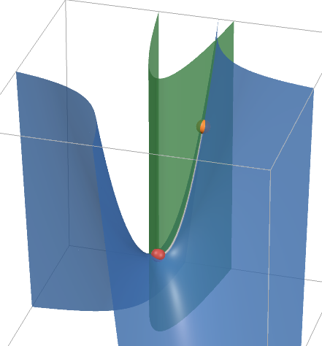
Arc length parameterization HW 13.3 / 4–5
Distance traveled along the curve:
$$s\left(t\right)=\int_{0}^{t}{\left|r^{'}\left(u\right)\right|du}$$
Solve for t in terms of s, then substitute into r(t).
Example: $r(t) = ⟨1+3t, 2t, 5t⟩$
Find s(t), measured from t = 0 in the direction of increasing t.
Reparameterize the curve in terms of arc length.

Distance along a curve HW 13.3 / 4–5
Using the same curve, find the point 5 units along the curve from (1, 0, 0), in the direction of increasing t.
Curvature
The curvature at a point, K, is a measure of how quickly a curve is changing direction at that point.
$$\frac{change in direction}{change in distance}=\left|\frac{d\overset{⃑}{T}}{ds}\right|$$
Roughly, how much does your direction change if you move a small amount (“one inch”) along the curve?
$$\left|\frac{\overset{⃑}{T_{2}}-\overset{⃑}{T_{1}}}{"one inch"}\right|=\left|\frac{∆\overset{⃑}{T}}{∆s}\right|$$

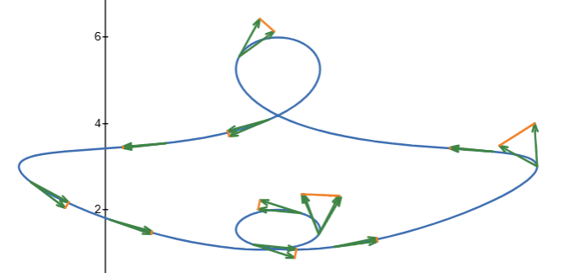
Visual: https://desmos.com/3d/ilgaxncxz6

This is NOT easy to compute directly from arc length, so instead we use this the following shortcut
$$K(t)= \left|\frac{d\overset{⃑}{T}}{ds}\right|=\frac{|{\overset{⃑}{r}}^{'}(t)×{\overset{⃑}{r}}^{''}(t)|}{{\left|{\overset{⃑}{r}}^{'}(t)\right|}^{3}}$$
(see the last page of these notes for proof or look in the text)

Sp’19 – Exam 1 – Loveless Like HW 13.3 / 6
Find the curvature of
$$r\left(t\right)=〈t^{3},3t^{2},6t〉$$
at t = 0.
Cool Side Fact
The radius of curvature is the radius of the circle that would best fit this curve.
$radius of curvature=\frac{1}{κ}$.
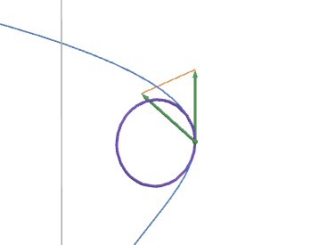
Visual: desmos.com/3d/rbjm1twka2
In 2D the curvature formula becomes
$$K\left(x\right)= \frac{\left|r^{'}×r^{''}\right|}{{\left|r^{'}\right|}^{3}}=\frac{|f^{''}\left(x\right)|}{{\left(1+{\left(f^{'}\left(x\right)\right)}^{2}\right)}^{3/2}}$$
(for proof, see the last page of these notes)

Example
Find the x-value at which curvature is maximum for $f(x) = x^{2}.$
Does your answer make sense?

What if you change to a different function?

Proofs of curvature formulas:
Proof of 3D shortcut formula (feel free to ignore)

Write v = |r′(t)|. Since r′ = vT, the product rule gives
$$r″ = v'T + vT'.$$
Take the cross product with r′ = vT. Note that $T × T$ = 0, since they are the same direction, so we get…
$$r' × r″ = v²(T × T').$$
Since |T| = 1 and T · T′ = 0 (so the angle is 90 degrees),
$$\left|T × T^{'}\right|=\left|T\right|\left|T^{'}\right|\sin\left({90}^{∘}\right)=\left|T^{'}\right|$$
Thus,
$$\left|r^{'}× r^{″}\right|=v^{2}\left|T^{'}\right|, so \left|T^{'}\right|=\frac{\left|r^{'}× r^{″}\right|}{v^{2}}$$
By definition
$$κ =\frac{\left|T^{'}\right|}{v}$$
And replacing $\left|T^{'}\right|=\frac{\left|r^{'}× r^{″}\right|}{v^{2}}$ gives the shortcut formula:
$$κ=\frac{\left|r^{'}× r^{″}\right|}{v^{3}}=\frac{\left|r^{'}× r^{″}\right|}{{|r^{'}|}^{3}}$$

Proof for 2D formula (again feel free to ignore)

For y = f(x), form the vector function
$$r\left(x\right)= 〈x,f\left(x\right),0〉$$
$$r^{'}(x)= 〈1,f^{'}\left(x\right),0〉$$
$$r''\left(x\right)= 〈0,f''\left(x\right),0〉$$
Taking the cross-product gives…
$$r^{'}× r^{″}=〈0,0,f''(x)〉$$
$$|r^{'}× r^{″}| = |f″(x)|$$
$$|r'(x)|= \sqrt{1+{f^{'}\left(x\right)}^{2}}$$
Thus,
$$K\left(x\right)= \frac{\left|r^{'}×r^{''}\right|}{{\left|r^{'}\right|}^{3}}=\frac{|f^{''}\left(x\right)|}{{\left(1+{\left(f^{'}\left(x\right)\right)}^{2}\right)}^{3/2}}$$

Proof sketch for the Arc Length formula
Step 1: Approximate the curve by short line segments.
Split a ≤ t ≤ b into small intervals.
On one interval, the length can be approximated by
$$L_{i} = \sqrt{(Δx_{i})² + (Δy_{i})² + (Δz_{i})²}.$$
Over a short time interval $Δt$, we can write…
$\sqrt{(Δx_{i})² + (Δy_{i})² + (Δz_{i})²}⋅\frac{Δt}{Δt}=\sqrt{{\left(\frac{Δx_{i}}{Δt}\right)}^{2} + {\left(\frac{Δy_{i}}{Δt}\right)}^{2} + {\left(\frac{Δz_{i}}{Δt}\right)}^{2}}⋅Δt$
Step 2: Add up the pieces, then take a limit.
$$L ≈ \sum_{i=1}^{n}{\sqrt{{\left(\frac{Δx_{i}}{Δt}\right)}^{2} + {\left(\frac{Δy_{i}}{Δt}\right)}^{2} + {\left(\frac{Δz_{i}}{Δt}\right)}^{2}}⋅Δt }.$$
As the interval width approaches zero, $\frac{Δx_{i}}{Δt}$approaches $x’(t_{i})$, $\frac{Δy_{i}}{Δt}$approaches $y’(t_{i})$ and $\frac{Δz_{i}}{Δt}$approaches $z’(t_{i})$. Thus, the sum on the right approaches an integral:
$$L =\int_{a}^{b}{\sqrt{x^{'}{\left(t\right)}^{2}+y^{'}{\left(t\right)}^{2}+z^{'}{\left(t\right)}^{2}}dt}= \int_{a}^{b}{|r^{'}\left(t\right)|dt}$$

Note: This derivation assumes r has a continuous derivative on [a, b].

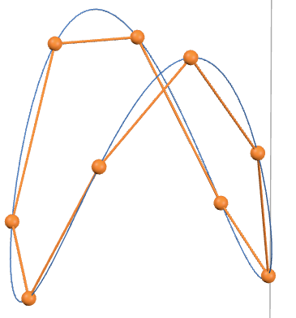

In 2D
$$L = \int_{a}^{b}{\sqrt{x^{'}{\left(t\right)}^{2}+y^{'}{\left(t\right)}^{2}}dt}$$
For a graph y = f(x), use x as the parameter:
$$r(x) = ⟨x, f(x)⟩,$$
$$r'(x) = ⟨1, f'(x)⟩.$$
Thus, the familiar formula from Math 125
$$L = \int_{a}^{b}{\sqrt{1+f^{'}{\left(x\right)}^{2}}dx}$$

